**Industrial Internship Report on**

**”isangeet : Your Fav Music Player”**

**Prepared by**

**[Anurag Singh]**

|  |
| --- |
| *Executive Summary* |
| This report provides details of the Industrial Internship provided by upskill Campus and The IoT Academy in collaboration with Industrial Partner UniConverge Technologies Pvt Ltd (UCT).  This internship was focused on a project/problem statement provided by UCT.  My project was (isangeet :Music Player): MusicFlow is an innovative and feature-rich music player app designed to provide users with an immersive and personalized music experience. With an intuitive interface and a wide range of capabilities, MusicFlow is the ultimate companion for music enthusiasts of all kinds.  This internship gave me a very good opportunity to get exposure to Industrial problems and design/implement solution for that. It was an overall great experience to have this internship. |

**TABLE OF CONTENTS**

1 Preface 3

2 Introduction 4

2.1 About UniConverge Technologies Pvt Ltd 4

2.2 About upskill Campus 8

2.3 Objective 9

2.4 Reference 9

3 Problem Statement 11

4 Existing and Proposed solution 12

5 Performance Test 14

5.1 Test Plan/ Test Cases 14

5.2 Test Procedure 14

5.3 Performance Outcome 14

6 My learnings 15

7 Future work scope 16

# Preface

This 6-week progress report provides an overview of the development and accomplishments of the MusicPlayer app. Over the past six weeks, My dedicated effort has made significant strides in designing, coding, and testing the app to bring an exceptional music playback experience to users. This report highlights key achievements, challenges faced, and upcoming milestones.

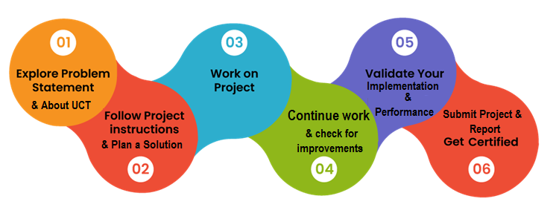

Creating a project, whether it's for a software project or any other endeavor, can be a valuable learning experience that provides insights into project management, communication, and documentation. Here's a reflection on the learning and overall experience gained from creating a report:

1. Project Understanding
2. Time Management
3. Problem Solving
4. Documentation Practice
5. Reflection and Improvement
6. Presentation Skill
7. Project Closure

Thanks to all (Upskill team) for providing me this opportunity and who have helped me in completing the project.

# Introduction

## About UniConverge Technologies Pvt Ltd

A company established in 2013 and working in Digital Transformation domain and providing Industrial solutions with prime focus on sustainability and RoI.

For developing its products and solutions it is leveraging various**Cutting Edge Technologies e.g. Internet of Things (IoT), Cyber Security, Cloud computing (AWS, Azure), Machine Learning, Communication Technologies (4G/5G/LoRaWAN), Java Full Stack, Python, Front end**etc.

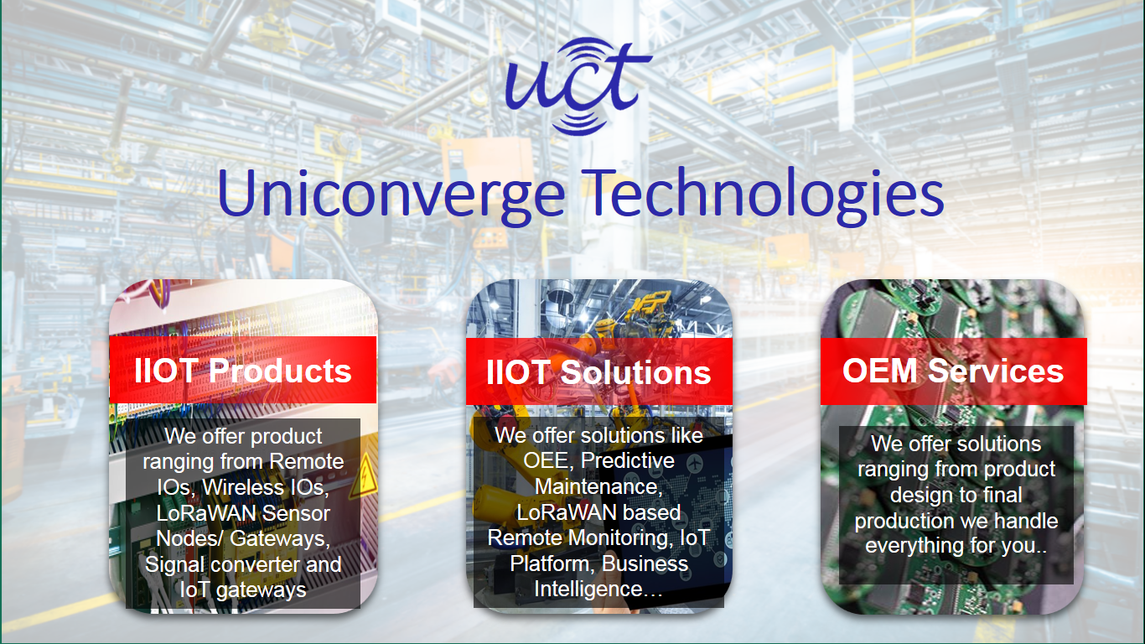

1. UCT IoT Platform **(****)**

**UCT Insight** is an IOT platform designed for quick deployment of IOT applications on the same time providing valuable “insight” for your process/business. It has been built in Java for backend and ReactJS for Front end. It has support for MySQL and various NoSql Databases.

* It enables device connectivity via industry standard IoT protocols - MQTT, CoAP, HTTP, Modbus TCP, OPC UA
* It supports both cloud and on-premises deployments.

It has features to  
• Build Your own dashboard  
• Analytics and Reporting  
• Alert and Notification  
• Integration with third party application(Power BI, SAP, ERP)  
• Rule Engine

 

1. **Smart Factory Platform (****)**

Factory watch is a platform for smart factory needs.

It provides Users/ Factory

* with a scalable solution for their Production and asset monitoring
* OEE and predictive maintenance solution scaling up to digital twin for your assets.
* to unleased the true potential of the data that their machines are generating and helps to identify the KPIs and also improve them.
* A modular architecture that allows users to choose the service that they what to start and then can scale to more complex solutions as per their demands.

Its unique SaaS model helps users to save time, cost and money.

 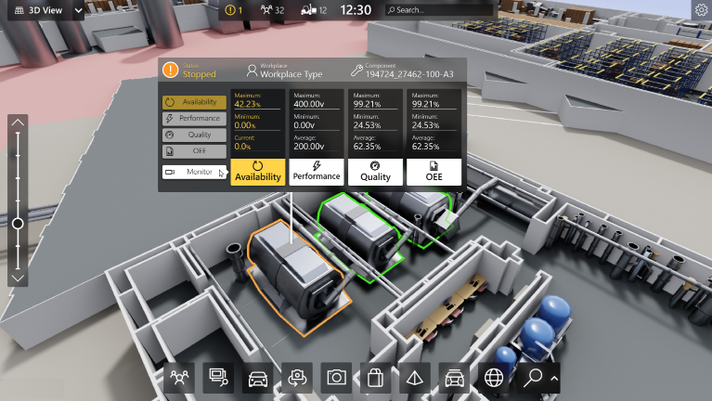

1. 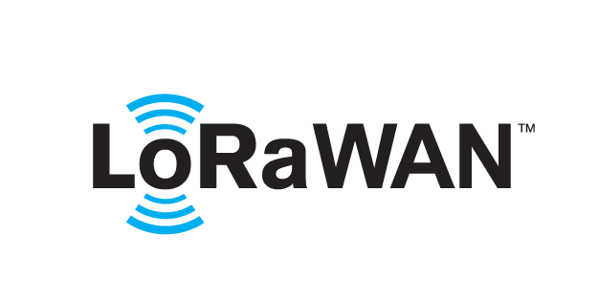 based Solution

UCT is one of the early adopters of LoRAWAN technology and providing solution in Agritech, Smart cities, Industrial Monitoring, Smart Street Light, Smart Water/ Gas/ Electricity metering solutions etc.

1. Predictive Maintenance

UCT is providing Industrial Machine health monitoring and Predictive maintenance solution leveraging Embedded system, Industrial IoT and Machine Learning Technologies by finding Remaining useful life time of various Machines used in production process.



## About upskill Campus (USC)

upskill Campus along with The IoT Academy and in association with Uniconverge technologies has facilitated the smooth execution of the complete internship process.

USC is a career development platform that delivers **personalized executive coaching** in a more affordable, scalable and measurable way.



Seeing need of upskilling in self paced manner along-with additional support services e.g. Internship, projects, interaction with Industry experts, Career growth Services

<https://www.upskillcampus.com/>

upSkill Campus aiming to upskill 1 million learners in next 5 year

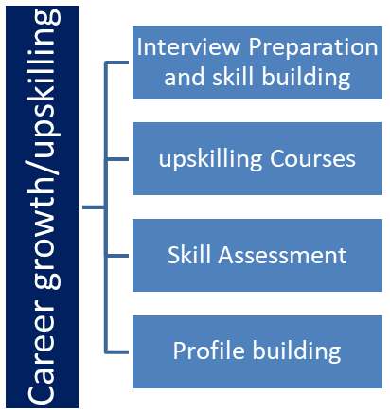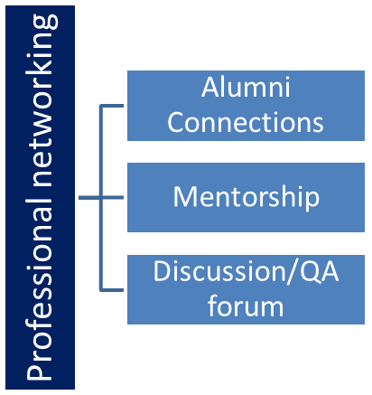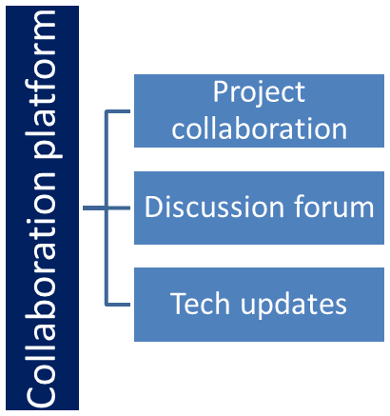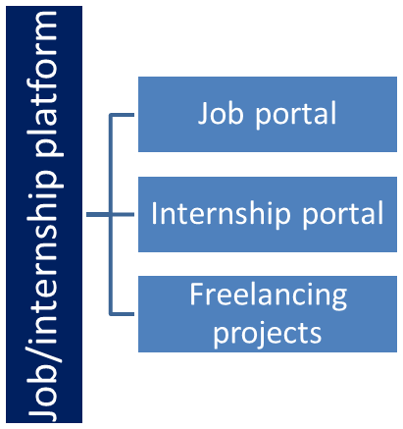

## The IoT Academy

The IoT academy is EdTech Division of UCT that is running long executive certification programs in collaboration with EICT Academy, IITK, IITR and IITG in multiple domains.

## Objectives of this Internship program

The objective for this internship program was to

 ☛ get practical experience of working in the industry.

 ☛ to solve real world problems.

 ☛ to have improved job prospects.

 ☛ to have Improved understanding of our field and its applications.

 ☛ to have Personal growth like better communication and problem solving.

## Reference

[1] Android Studio Documentation

[2] Code with Harry playlist for creating an app.

[3] Java Documentation to implement Java API.

# Problem Statement

In the assigned problem statement

Develop a music player application that allows users to play, manage, and enjoy their music collection. The music player should provide essential functionalities for organizing and playing music files in various formats.

Minimum Features for a Music Player:

1. Music Playback: Users should be able to play, pause, and stop music playback.

- Output: The music player starts playing the selected song and displays basic playback controls such as play, pause, and stop.

2. Playlist Management: Users should be able to create and manage playlists.

- Output: Users can create a new playlist, add songs to the playlist, and view and modify existing playlists.

3. Music Library Organization: Users should be able to browse and select songs from their music library.

The music player displays a list of available songs in the library. Users can select a song to play.

4. Basic Navigation: Users should be able to navigate through the music library and playlists.

- Output: Users can browse through their music library, view songs by artist, album, or genre, and switch between different playlists.

5. Audio Control: Users should be able to adjust the volume of the music playback.

- Output: Users can increase or decrease the volume of the music player, and the output audio volume changes accordingly.

The expected output for these minimum features includes a functional music player interface with basic playback controls, the ability to create and manage playlists, the ability to browse and select

songs, basic navigation features, and audio control capabilities. The player should provide a seamless experience for users to play and manage their music collection with ease.

# Existing and Proposed solution

1. **User Interface Refinement:** We have finalized the app's user interface design, focusing on intuitive navigation and a visually appealing layout that enhances the overall user experience.
2. **Core Music Playback:** The foundation for seamless music playback has been successfully implemented. Users can now browse their music libraries, select songs, and enjoy uninterrupted audio.
3. **Playlist Creation:** Users can create and manage their playlists, providing a personalized music selection for different moods and occasions

.

1. **Audio Quality Optimization:** Significant progress has been made in optimizing audio quality, ensuring that users enjoy crisp and clear sound during playback.
2. **Basic Theme Customization:** Users can choose from a limited selection of themes to personalize the app's appearance to their liking.

## Code submission (Github link)

## Report submission (Github link) : first make placeholder, copy the link.

# Proposed Design/ Model

1. **User Interface (UI):**
   * Song List View: Displays a list of available songs.
   * Playback Controls: Play, pause, next, previous buttons.
   * Progress Bar: Shows the current playback progress.
   * Volume Control: Adjusts the volume level.
   * Playlist Management: Create, edit, and delete playlists.
2. **Playback Engine:**
   * Audio Player: Manages audio playback using the device's audio APIs.
   * Playlist Manager: Handles playlist creation, editing, and retrieval.
3. **Data Management:**
   * Song Database: Stores metadata (e.g., title, artist, album) of available songs.
   * Playlist Database: Stores user-created playlists and their associated songs.
4. **User Input Handling:**
   * UI Event Handler: Captures user interactions with the UI elements.
   * Gesture Recognizer: Detects gestures for interactions like tapping, swiping, etc.
5. **Audio Control:**
   * Audio Decoder: Converts audio files into playable formats.
   * Audio Mixer: Manages audio playback and volume control.

## High Level Diagram

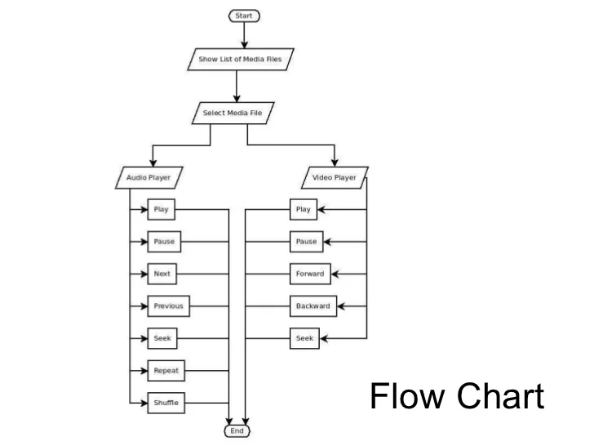

Figure 1: HIGH LEVEL DIAGRAM OF THE SYSTEM

## Interfaces

**Music Player(Audio Files) : First Activity**

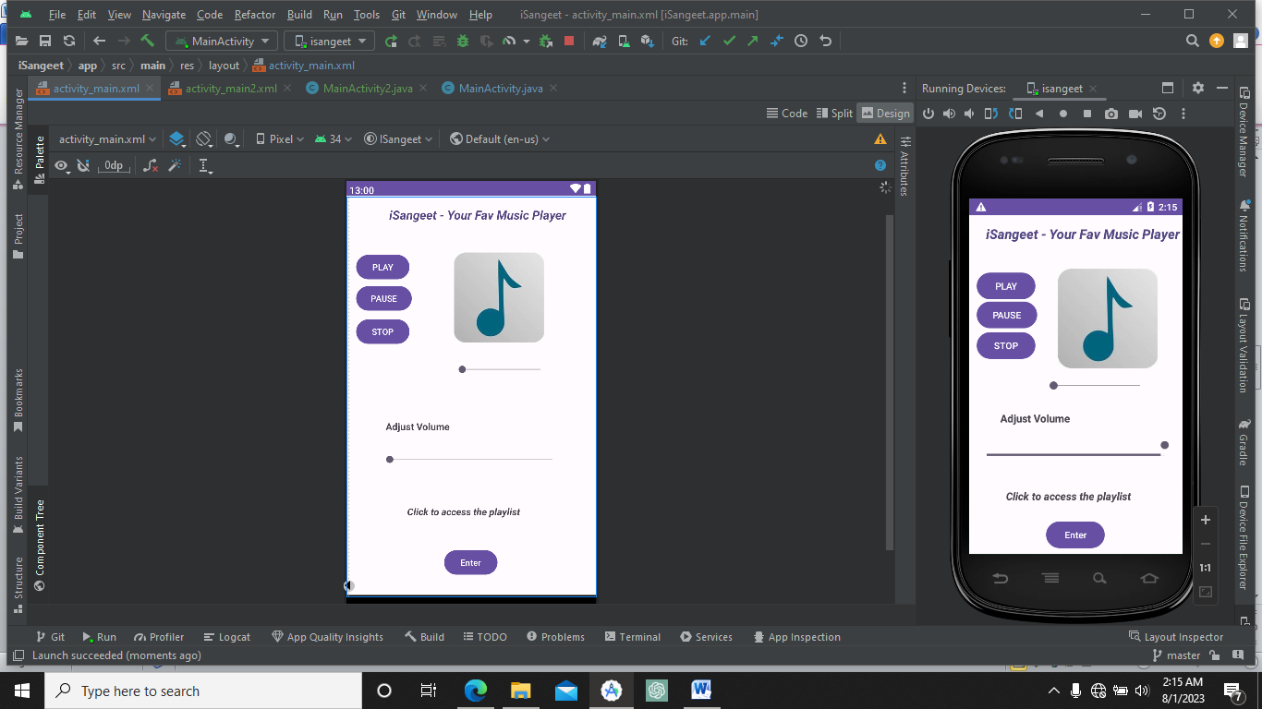

**Music Player(Video Files) : Second Activity**

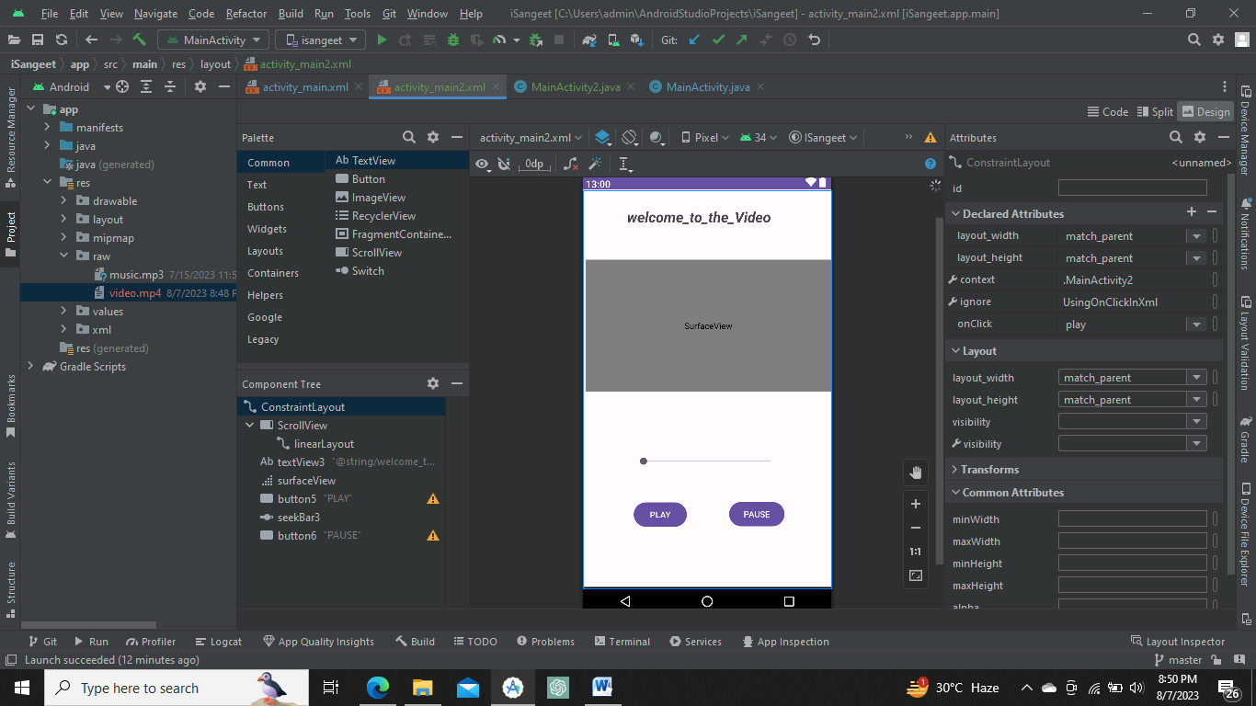

# Performance Test

Performance testing helped to ensure that our music player app functions smoothly and efficiently, providing a seamless experience to users

1. **Performance Metrics:**

* App launch time: As the SDK used while creating music player is Ore 8.0 so it is compatible with almost 99.8% mobile phone
* Song loading time: As the API used to build an application is 34 hence it enable smooth loading of music files.
* Playback start time: As the API used to build an application is 34 hence it enable smooth starting of music files.
* Playback responsiveness (play/pause): As the API used to build an application is 34 hence it enables smooth play and pause functionalities of music files.

2**. Load Testing:**

* 1. Load the app with a small music library enable smooth proce
  2. Load the app with a large music library crashes the app does not allow to load even the interface.

1. **Song Loading Performance:**

The app slight delay about 5 – 10 sec while playing the music file.

# 7.My learnings:

Valuable insights and learning experiences are:

1. **Project Management:** Writing a report requires you to review the entire project, helping you understand how project management principles were applied, from planning and resource allocation to tracking progress and meeting milestones.
2. **Clear Communication:** Summarizing complex technical details in a clear and concise manner enhances your communication skills. You learn to convey information effectively to both technical and non-technical stakeholders.
3. **Documentation Skills:** Creating a report strengthens your ability to document project phases, design decisions, challenges faced, and solutions implemented. This practice fosters effective knowledge sharing within your team and beyond.
4. **Problem Solving:** Reflecting on challenges encountered during the project and explaining how you overcame them showcases your problem-solving skills. This can help you approach similar issues more effectively in future projects.
5. **Technical Knowledge:** Writing about the app's design, architecture, and features reinforces your understanding of the technical aspects of software development, making you more proficient in the technologies you used.
6. **Time Management:** Crafting a report requires effective time management to gather data, analyze results, and write content. This experience hones your ability to manage your time efficiently.
7. **Presentation Skills:** Presenting your report to stakeholders or colleagues can enhance your presentation skills, as you learn to communicate your findings and insights confidently.
8. **Continuous Improvement:** The report-writing process promotes a culture of continuous improvement. By identifying lessons learned and future recommendations, you contribute to the iterative enhancement of your skills and projects

# Future work scope

**1. Advanced Theme Customization:**

* Introduce a comprehensive theme customization feature.
* Allow users to choose from a wide range of color schemes, backgrounds, and visual elements to personalize the app's appearance.

**2. Lyrics Integration:**

* Integrate a lyrics display feature that synchronizes lyrics with the currently playing song.
* Enable users to sing along, enhancing their connection to the music.

**3. Online Mode Enhancements:**

* Improve the online mode by enabling users to download entire playlists or albums for online listening.
* Implement an automatic synchronization feature to ensure online content is up-to-date.

**4. Social Sharing and Collaboration:**

* Enable users to share their favorite songs, playlists, and music discoveries on social media platforms directly from the app.
* Introduce collaborative playlist creation, allowing users to collaborate with friends in curating playlists.

**5. Voice Commands and Integration:**

* Implement voice control functionality to allow users to control playback, search for songs, and perform other actions using voice commands.
* Integrate with virtual assistants (e.g., Siri, Google Assistant) to provide a hands-free music playback experience.

**6. Smart Recommendations:**

* Utilize machine learning algorithms to provide personalized song recommendations based on user listening habits, preferences, and mood.